|  |  |  |
| --- | --- | --- |
| **شعار جامعة بنها الجديد**f |  | **logo.jpg** |
| Benha University |  | Faculty of Computers & Informatics |

**Hotel Mangment System**

A summer training project submitted in partial fulfillment of the requirementsfor the degree of Bachelor of Computers and Informatics.

**1st Year Students Summer Training**

*Project Team*

1. Ahmed Khaled mawed
2. Ahmed Khaled Hassan
3. Ibrahim Amr
4. Ibrahim saeed Hamed
5. Ahmed Ayman Abo Elenien
6. Ahmed Osama Mohmed Fathi

Benha, August 2018

We hereby certify that this project, submitted by the project teamwork, conforms to acceptable standards and is fully adequate in scope and quality to fulfill the seminar requirements for the degree of Bachelor of Computers and Informatics.

**Discussion Committee:**

____________________________________ ________________

Date

____________________________________ ________________

Date

____________________________________ ________________

Date

**Abstract**

BFCI hotel is a project to help receptionest to Enter customer data with some services parking, souna,Gym, house keeping, swimming pool,etc...

we have 30 room (single,double,bronze)

Single room costs 300$ and we offer to the customer

1-break fast,dinner

2-house keeping

3-parking

Double room costs 500$ and we offer to the customer .

1-break fast,dinner

2--house keeping

3-parking

4-swimming pool

Bronze room costs 1000$ and we offer to the customer .

1-break fast,dinner

2--house keeping

3-souna

4-swimming pool

5-Gym

6-Tennis

visit us to find whatever you like..

**Introduction**

An introduction stating the problem definition and an overview of the solution detailed in the following sections of the document is given. The introduction may contain some information and comments about the nature of the problem, literature survey, approaches used in the literature to tackle this and similar problems, etc. It may also include some necessary terminology and definitions that will be used throughout the document; in the case that there are plenty of terminology and definitions, they may be written in a separate section.

**Program Interface**

**The user starts to execute the program by clicking on the word password and then another window will appear asking him to write the name and password number and show another window and the main window from which to record all data and save in a file writes all data and press the add button and then click on Save if he wants To save the data in the file and if wanted to do a search by the national number of the client to modify a specific or exit from the hotel there is a search button that searches the file in the national number and show data on the screen and then delete or modify the data if he wants and if he wants to exit the program press the button Exit ..**

**Program Execution**

The program outputs are all data recorded in this program in terms of name, national number, time period to be spent by the customer in the hotel, room type, room number, total price, time of registration, and assistance. Such as cleaning button and update…

**Input and Output**

The format of the input and output will be explained in this section. If the program also gets some input from input files and produces some output on output files, then the exact format of the files must also be given. It is advisable to include some example inputs and outputs, and their explanations.

**Program Structure**

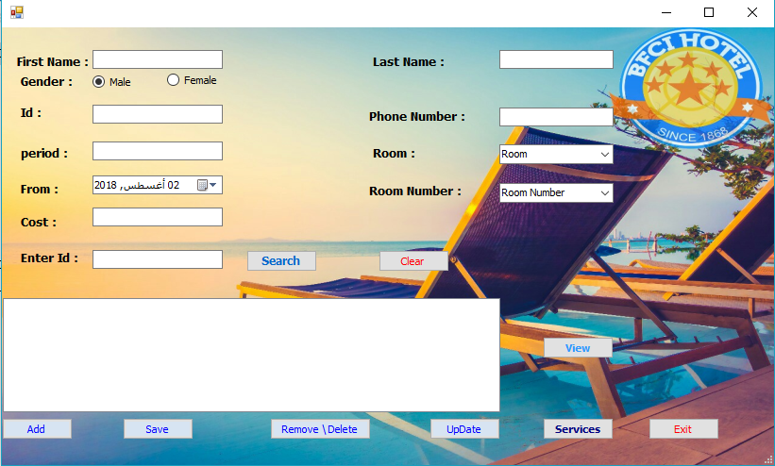

In this picture we show all the options that will be used by the user to add the data is modified or saved in the file or deleted information and so we will explain all the codes and data for all the equations in the discussion…

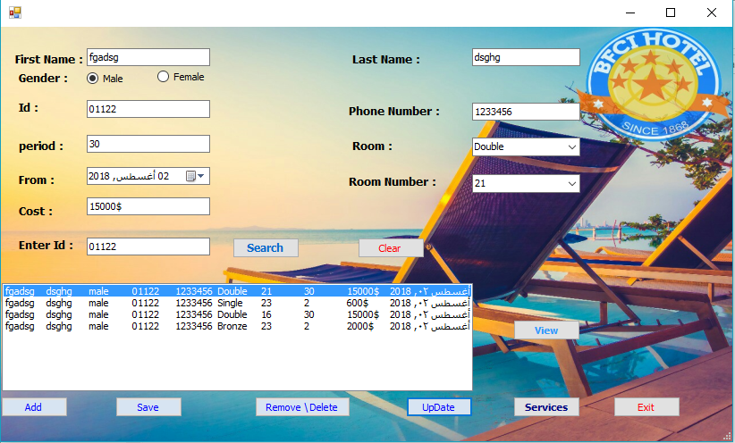**Examples**

**This window shows most of the buttons that we use from the add - on and so will be further clarified in the discussion through the team**

**Improvements and Extensions**

There are defects to the program, which is a very serious flaw so that when the customer registers that in his room number 1 p, for example the number one can take time to another to another customer and thus the system fails and the idea did not notify the team and will be developed in the near future God willing**...**

**Difficulties Encountered**

**There were a lot of difficulties and problems that we were ignorant of and did not know the solution, but research and assistant engineers have solved and increased our experience in solving problems…**

**Conclusion**

There are no conclusions of the project, but this project is integrated from all the options and assistance that will be needed by the user with errors or mistakes and will work to solve them in the near future